Please Note: | No Chairs or tables provided.  The fee entitles you entry for one vehicle only.  No food, drinks, or ice cream products to be sold at any show.

2020 show dates:  Friday 8th May | Show  Please indicate which show(s) you would like to attend  Tick  Crow Nest Park, Heckmondwike Road, Dewsbury  WF13 2SG
Sunday 14th June | Lock Park, Park Road, Barnsley S70 1YJ
Sunday 9th August | Locke Park, Park Road, Barnsley S70 1YJ
Sunday 6th September | Kirklees Light Railway, Park Mill Way,  Clayton West, Huddersfield HD8 9XJ
Sunday 4th October | Crow Nest Park, Heckmondwike Road, Dewsbury  WF13 2SG
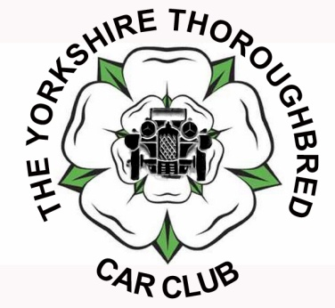
www.ytcc.co.uk
Yorkshire Thoroughbred Car club
Stallholder Application 2020
Charge per single stall per show £10.00
Please make cheques payable to YTCC (WR) and return to David Lloyd, 7 Cliff Grove, Crigglestone, Wakefield, WF4 3EP with a SAE for return of pass.
Any enquiries to: David Lloyd 10924 251541 or mobile: 07751 668781.
Email: davbrolloyd@mail.com
Please complete in full:
Name: ______________________________________________________________________
Address:____________________________________________________________________
_____________________________________________________________________
_____________________________________________________________________
Postcode: _____________________ Mobile: ______________________________________
Tel: ___________________________Type of goods sold: _____________________________

